**The complete SANCLA guide to WSUS maintenance**https://github.com/SANCLA/WSUS-Maintenance

Tips 1

Documentation 1

Install the necessary tools 1

Configure Internet Information Services 2

Configure the SQL Server (WID) 4

Configure the WSUS maintenance script 6

# Tips

* SQL server (Express if no full SQL server available *) is preferred, instead of the default WID database.
* Configure the WSUS server properly (see documentation links)
* Configure the Group Policy!  
  (and take into account the users/laptops who seldom connect to your network)

* Limitations SQL server Express:

* 1GB maximum memory used by the SQL Server Database Engine
* The maximum size of each relational database is 10GB
* SQL Agent is not included in Express. The SQL Agent is a background tool which enables administrators to automate tasks like backing up data, database replication setup, job scheduling, user permissions, and database monitoring.
* The limit on the buffer cache for each instance is 1MB of RAM.
* The relational database engine is restricted to the lesser of 1 socket or 4 cores.

# Documentation

1. Microsoft - Plan your WSUS deployment  
   <https://docs.microsoft.com/en-us/windows-server/administration/windows-server-update-services/plan/plan-your-wsus-deployment>
2. How I build and maintain WSUS Server  
   <https://www.meinekleinefarm.net/how-i-build-and-maintain-wsus-server/>

# Install the necessary tools

1. Download the latest SQL Management Studio  
   <https://docs.microsoft.com/en-us/sql/ssms/download-sql-server-management-studio-ssms?view=sql-server-2017>

# Configure Internet Information Services

1. Open Internet Information Services (IIS) Manager
2. Goto Application Pools and open the Advanced Settings of the WsusPool  
   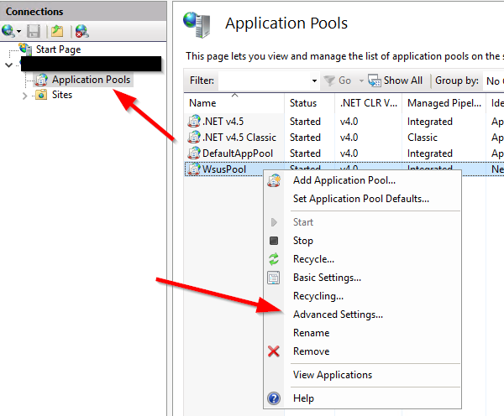
3. Change the Queue Length to “5000”  
   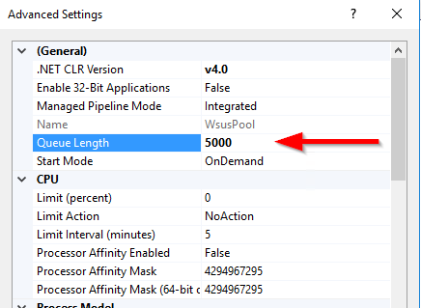
4. Change the Limit Action to “Throttle”  
   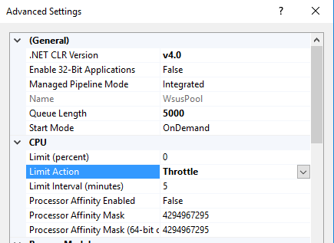
5. Change the Private Memory Limit to “4000000”  
   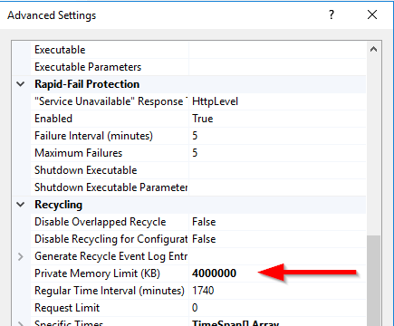

# Configure the SQL Server (WID)

1. Open the SQL Management Studio, preferrebly with the same (administrator) account that u used to install the WSUS with.
2. Connect to the WID database server  
   2003/2008: \\.\pipe\MSSQL$MICROSOFT##SSEE\sql\query

2012/2016: \\.\pipe\MICROSOFT##WID\tsql\query

1. Select the SQL server and open the properties  
   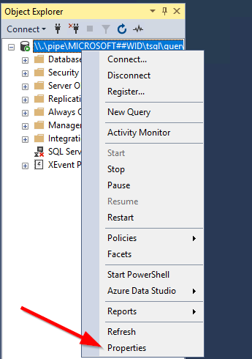
2. Goto Connections and set the “Remote query timeout” value to 0 (unlimited).  
   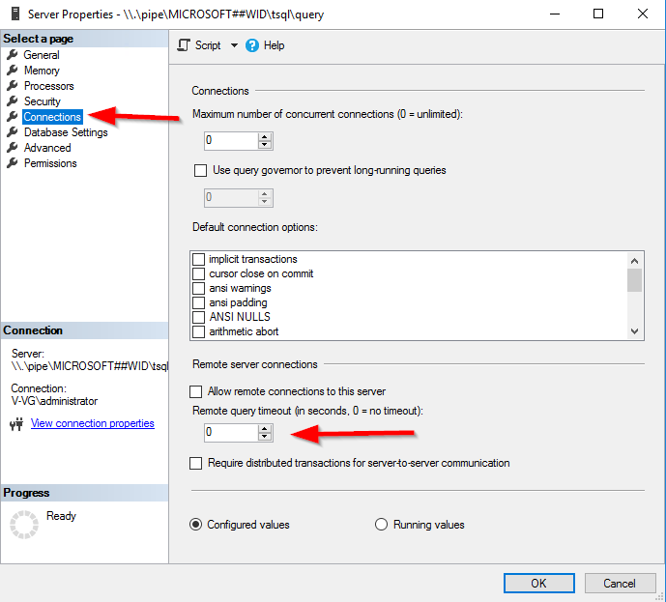
3. Save and close everything

# Configure the WSUS maintenance script

1. Download the latest script version from Github:  
   <https://github.com/SANCLA/WSUS-Maintenace>
2. Configure the script as a service, follow the instructions in the readme.docx file
3. First time you run the script, it can take a long time to finish…